Q 2.1 Eight Point Algorithm

Image displayEpipolarF:

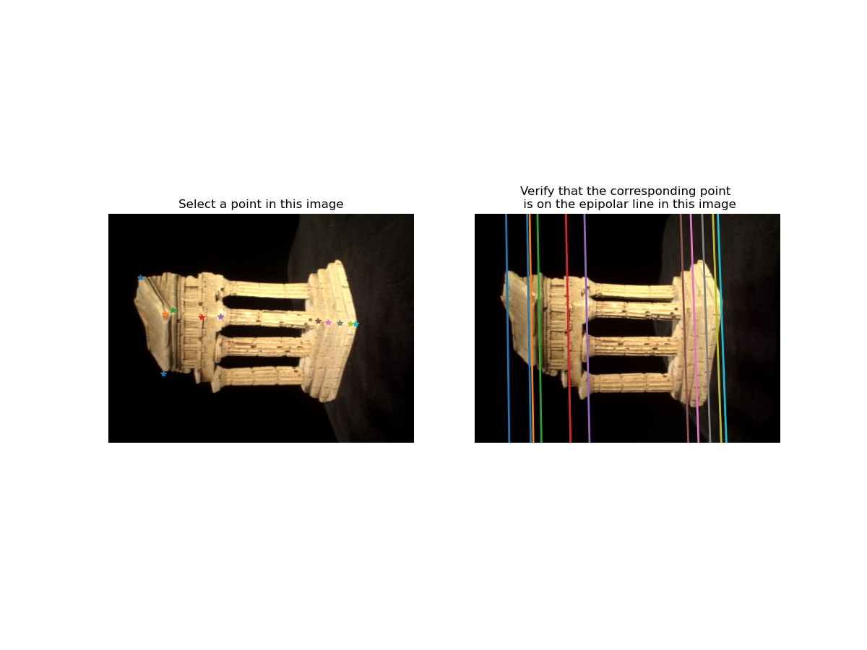

Recovered F:



Q 3.1 Essential Matrix

Computed with F8:



Q 4.1 Epipolar Match GUI

Image Result:

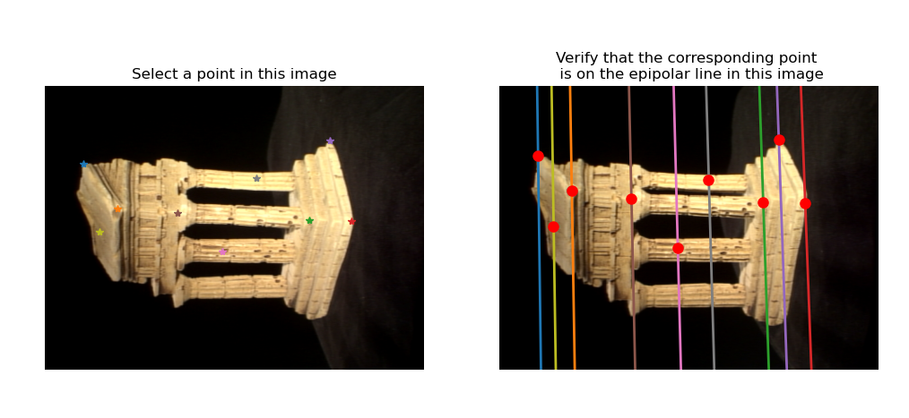

Q 4.2 3D Visualization

Visualization:

TopView: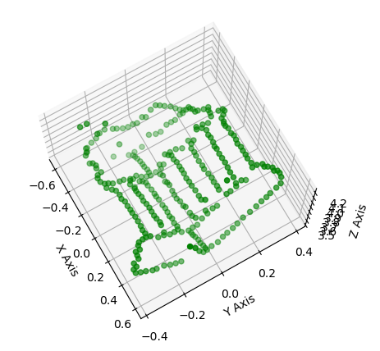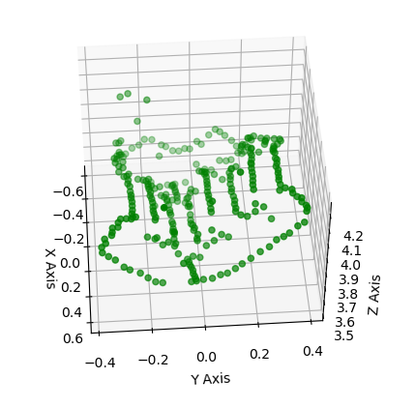

Side View: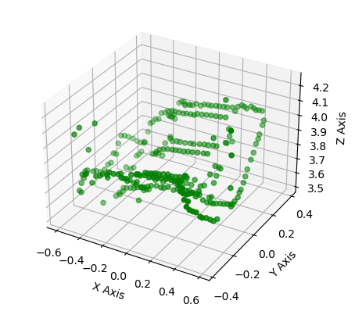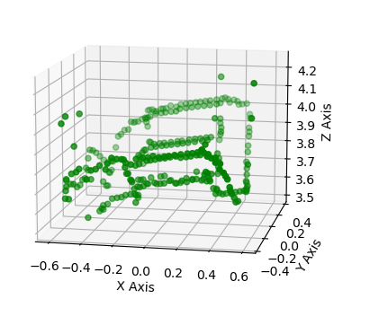

Bottom View: 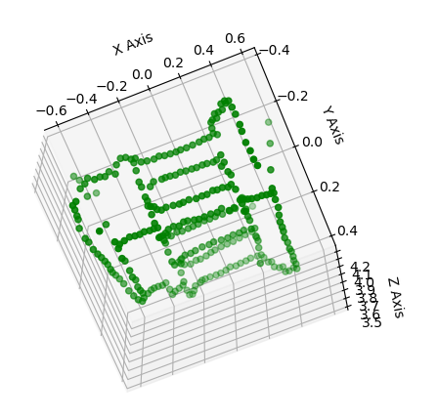

Q 5.1 RANSAC

Parameters used: 500 iterations & 0.001 tolerance

The result using the RANSAC method is so much better than that of the ordinary eight point algorithm, where the lines are too zoomed out of the image. The tolerance value improves streamlined the inliers. With reducing tolerance from 5 to 0.001, my inliers streamlined from 140 to 102. 75% of the correct data points are in the 109 ballpark. 500 iterations is enough to get as many possibilities and not taking too long. Error matrix is set to be (x2.t)(F)(x2) and have it as close to 0 as possible.

Ordinary eight point algorithm:

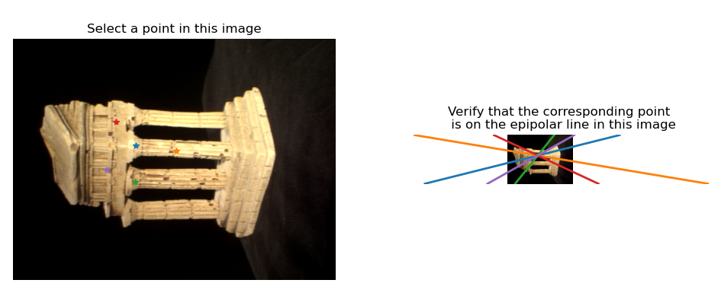

RANSAC method:

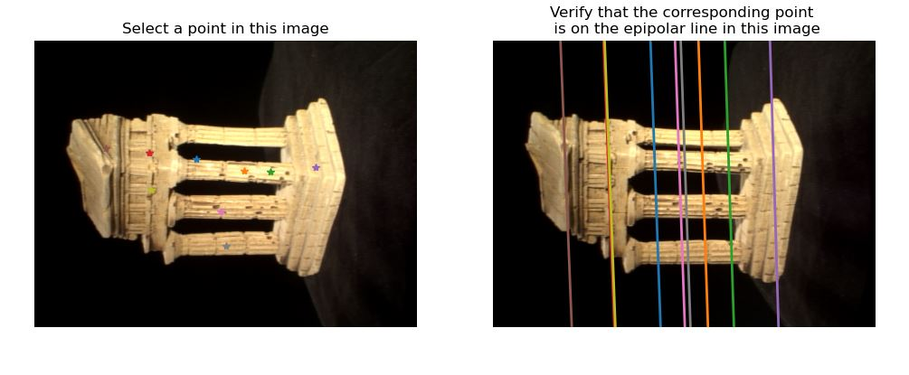

Q 5.2 Rodrigues

5.3 Residuals

Data are not able to be computed, but the functions should work. Partial points please.